DATA ENGINEERING

ASSESSMENT 7

Delta Lake Type 1 SCD Merge Workflow
Student | Subject
Abhishek Sethi | Data Engineering

Table of Contents
Update this table in Microsoft Word (References → Update Table) to display page numbers.

1. Assignment Details
A Delta Lake Type 1 slowly changing dimension workflow maintains a Superstore master table from baseline and incremental CSV files.

2. Aim
To ingest, clean, store, merge, and validate incremental Superstore data using Apache Spark and Delta Lake.

3. Problem Statement
A master dataset and an incremental batch must be combined so matched identifiers receive current values and new identifiers are inserted without retaining historical versions.

4. Objectives
- Read baseline and incremental CSV inputs.
- Make column names storage-safe and standardize identifier names.
- Remove duplicate keys and fill missing city/state values.
- Persist an initial Delta table.
- Perform a Type 1 Delta MERGE by ID.
- Validate final row count and duplicate identifiers.

5. Technologies and Environment
Area | Actual technology
Language | Python
Processing | Apache Spark / PySpark 3.5.0
Storage | Delta Lake 3.2.0, local Delta tables
Notebook | Jupyter Notebook
Dependencies | delta-spark, local Delta Spark and storage JAR files

6. Dataset/Input Description
Input | Purpose
Sample - Superstore.csv | Baseline Superstore master records.
superstore_incremental.csv | Changed and new records for merge.
customer_master.csv / customer_incremental.csv | Inputs used by the separate verification script.

7. Schema and Data Characteristics
The notebook standardizes the Superstore source into fields such as ID, OrderID, CustomerID, CustomerName, City, State, Sales, and Profit. Delta storage paths include superstore_master and customer_master.

8. Concepts Used
- Delta Lake ACID table storage and transaction logs.
- Type 1 slowly changing dimension merge logic.
- CSV ingestion and schema normalization.
- Deduplication and missing-value completion.
- DeltaTable MERGE matched-update and not-matched-insert operations.
- Validation through row counts and duplicate-ID checks.

9. Solution Architecture/Workflow
Stage | Input | Processing | Output
Load | Baseline CSV | Read with header/schema inference. | Raw Spark DataFrame.
Clean | Raw data | Safe columns, renamed keys, de-duplicate ID, fill City/State. | Master DataFrame.
Store | Clean master | Write Delta format. | Initial Delta table.
Merge | Incremental CSV + Delta target | Matched IDs update City/State/Sales/Profit; unseen IDs insert. | Current Type 1 table.
Validate | Merged Delta table | Count rows and check duplicate IDs. | Verified final dataset.

10. Methodology
The implementation loads the baseline Superstore extract, standardizes its columns, removes duplicate IDs, fills missing locations, and writes Delta storage. It loads the incremental batch and executes a Delta MERGE on ID. The final table is displayed and tested for total rows and duplicate IDs. The separate validation script repeats the same Type 1 pattern on customer data.

11. Complete Implementation
Complete final code from the supplied notebook and validation script follows.
from pathlib import Path
from pyspark.sql import SparkSession
from delta.tables import DeltaTable

# Resolve the project and dependency locations
project_dir = Path.cwd().resolve()
if not (project_dir / "data").exists() and (project_dir.parent / "data").exists():
project_dir = project_dir.parent

delta_jar = str(project_dir / "delta-spark_2.12-3.2.0.jar")
storage_jar = str(project_dir / "delta-storage-3.2.0.jar")
delta_table_path = str(project_dir / "delta_tables" / "superstore_scd")

spark = SparkSession.builder \
.appName("Delta_SCD_Pipeline") \
.master("local[*]") \
.config("spark.jars", f"{delta_jar},{storage_jar}") \
.config("spark.sql.extensions", "io.delta.sql.DeltaSparkSessionExtension") \
.config("spark.sql.catalog.spark_catalog", "org.apache.spark.sql.delta.catalog.DeltaCatalog") \
.getOrCreate()

spark.sparkContext.setLogLevel("ERROR")
print("Spark Session with Delta Lake support created successfully.")

master_csv = str(project_dir / "data" / "Sample - Superstore.csv")
master_raw = spark.read.option("header", True).option("inferSchema", True).csv(master_csv)

print(f"Ingested baseline master CSV containing {master_raw.count()} records.")

# Make column names storage-safe by replacing spaces and symbols
clean_cols = [c.replace(" ", "_").replace("-", "_") for c in master_raw.columns]
master_df = master_raw.toDF(*clean_cols)

# Rename identifier fields to the chosen convention
master_df = master_df.withColumnRenamed("Row_ID", "ID") \
.withColumnRenamed("Order_ID", "OrderID") \
.withColumnRenamed("Customer_ID", "CustomerID") \
.withColumnRenamed("Customer_Name", "CustomerName") \
.withColumnRenamed("Postal_Code", "PostalCode")

master_df = master_df.dropDuplicates(["ID"])
master_df = master_df.na.fill({"City": "Unknown", "State": "Unknown"})

master_df.printSchema()

# Persist the initial dataset to the local Delta path
master_df.write.format("delta").mode("overwrite").save(delta_table_path)
print(f"Initial baseline Delta table successfully created at: {delta_table_path}")

incremental_csv = str(project_dir / "data" / "superstore_incremental.csv")
incremental_raw = spark.read.option("header", True).option("inferSchema", True).csv(incremental_csv)

print(f"Ingested {incremental_raw.count()} incremental update records.")

# Bring the incremental fields into line with the master fields
inc_clean_cols = [c.replace(" ", "_").replace("-", "_") for c in incremental_raw.columns]
incremental_df = incremental_raw.toDF(*inc_clean_cols)

incremental_df.show(5, truncate=False)

print("Opening delta storage folder to initiate merge...")
delta_target = DeltaTable.forPath(spark, delta_table_path)

(
delta_target.alias("target")
.merge(
incremental_df.alias("source"),
"target.ID = source.ID"
)
.whenMatchedUpdate(set={
"City": "source.City",
"State": "source.State",
"Sales": "source.Sales",
"Profit": "source.Profit"
})
.whenNotMatchedInsertAll()
.execute()
)
print("Delta MERGE (SCD Type 1) finished successfully.")

# Open the Delta table after the merge
final_df = spark.read.format("delta").load(delta_table_path)

print("Preview of updated records:")
final_df.orderBy("ID") \
.select("ID", "CustomerName", "City", "State", "Sales", "Profit") \
.show(15, truncate=False)

# Perform the final data-quality checks
total_rows = final_df.count()
duplicate_count = final_df.groupBy("ID").count().filter("count > 1").count()

print(f"Validation Results:")
print(f" - Total records post-merge: {total_rows}")
print(f" - Duplicate ID occurrences: {duplicate_count}")

# End the Spark session
spark.stop()

# Standalone validation script
from pathlib import Path
from pyspark.sql import SparkSession
from delta.tables import DeltaTable

# Establish the project file paths
working_dir = Path.cwd()
delta_jar = working_dir / 'delta-spark_2.12-3.2.0.jar'
delta_storage_jar = working_dir / 'delta-storage-3.2.0.jar'
delta_db_path = working_dir / 'delta_tables' / 'customer_master'

# Create the configured Spark session
spark = SparkSession.builder \
.appName('Delta_SCD1_Validation') \
.master('local[*]') \
.config('spark.jars', f'{delta_jar},{delta_storage_jar}') \
.config('spark.sql.extensions', 'io.delta.sql.DeltaSparkSessionExtension') \
.config('spark.sql.catalog.spark_catalog', 'org.apache.spark.sql.delta.catalog.DeltaCatalog') \
.getOrCreate()

spark.sparkContext.setLogLevel('ERROR')

# Read and prepare the initial customer dataset
raw_customers = spark.read.option('header', True).option('inferSchema', True).csv('data/customer_master.csv')
cleaned_customers = raw_customers.dropDuplicates(['ID', 'Name', 'City']).na.fill({'City': 'Mumbai'})
cleaned_customers.write.format('delta').mode('overwrite').save(str(delta_db_path))

# Read the incoming change records
update_customers = spark.read.option('header', True).option('inferSchema', True).csv('data/customer_incremental.csv')

# Apply the Type 1 Delta merge
delta_table = DeltaTable.forPath(spark, str(delta_db_path))
(
delta_table.alias('target')
.merge(update_customers.alias('source'), 'target.ID = source.ID')
.whenMatchedUpdate(set={'Name': 'source.Name', 'City': 'source.City'})
.whenNotMatchedInsertAll()
.execute()
)

# Check the merged table for expected quality conditions
final_records = spark.read.format('delta').load(str(delta_db_path))
final_records.orderBy('ID').show(truncate=False)

print('row_count=', final_records.count())
print('duplicate_ids=', final_records.groupBy('ID').count().filter('count > 1').count())

spark.stop()

12. Important Code Sections
Section | Explanation
Spark configuration | Configures local Spark with Delta extension/catalog and supplied JAR dependencies.
Master cleaning | Renames identifiers, drops duplicate IDs, fills City/State.
Initial Delta write | Stores baseline master in Delta format.
MERGE | Updates matched ID values and inserts unmatched records, implementing Type 1 behavior.
Validation | Displays final values, counts records, and checks duplicate IDs.

13. Execution Steps
pip install -r requirements.txt
python verify_delta_merge.py
Run the notebook cells sequentially from the project environment; the README records expected validation values row_count = 4 and duplicate_ids = 0 for the standalone customer validation.

14. Output Screenshots
Figure 1: screenshots\data_cleaning\image.png — execution evidence for data loading, cleaning, SCD Type 1/2 work, validation, or final output.
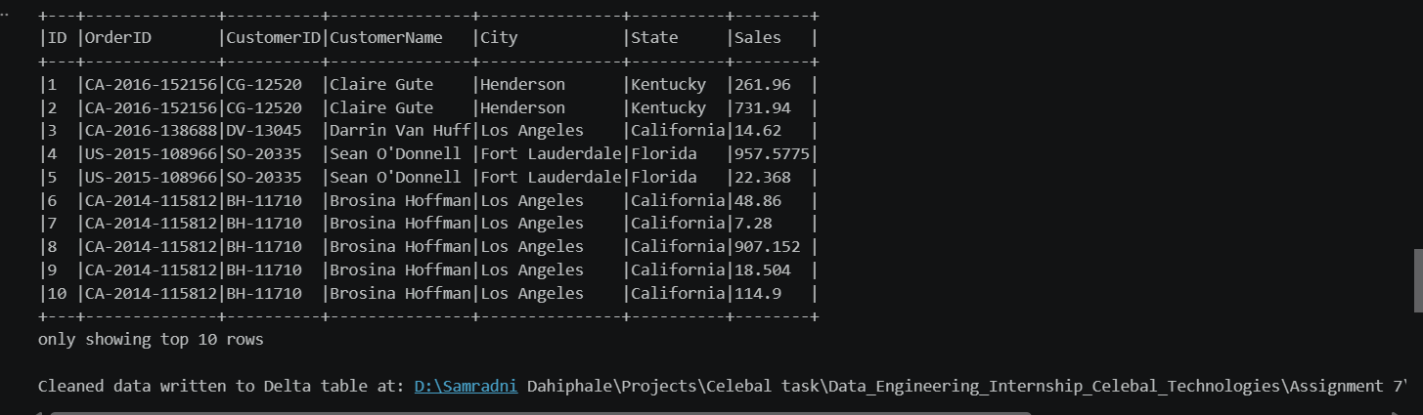
Figure 2: screenshots\data_cleaning\image1.png — execution evidence for data loading, cleaning, SCD Type 1/2 work, validation, or final output.
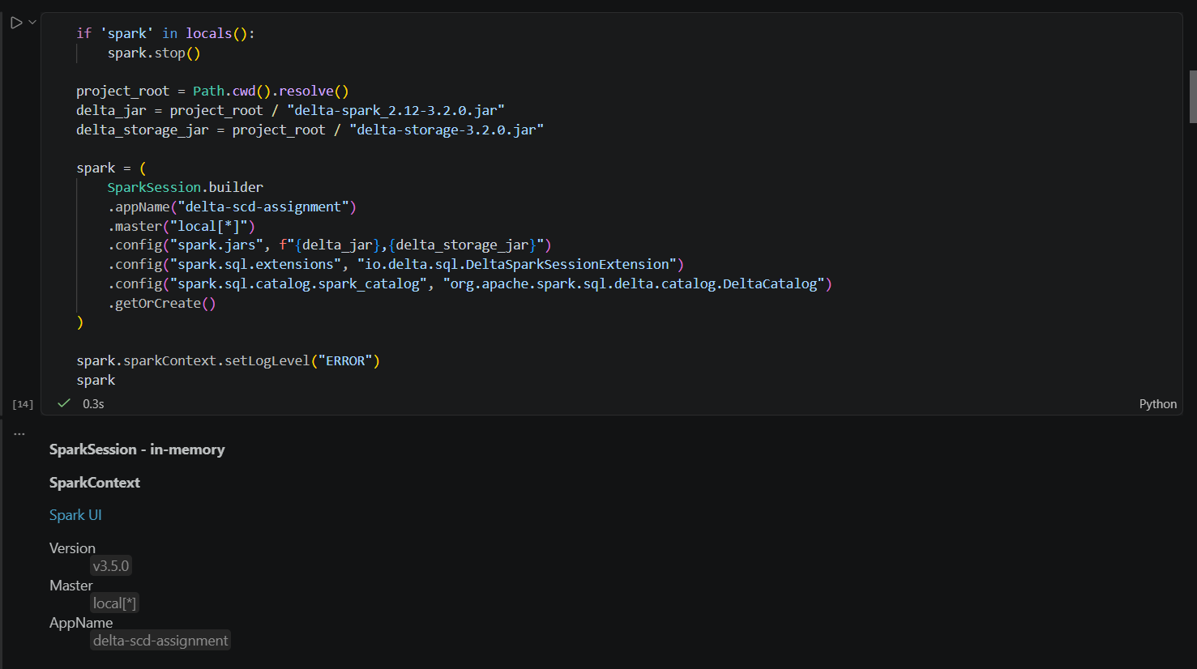
Figure 3: screenshots\data_loading\image.png — execution evidence for data loading, cleaning, SCD Type 1/2 work, validation, or final output.
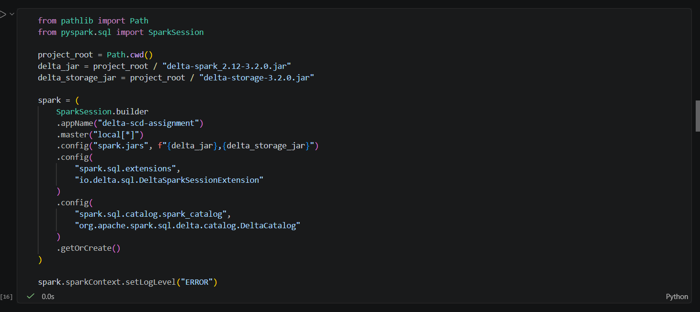
Figure 4: screenshots\data_loading\image1.png — execution evidence for data loading, cleaning, SCD Type 1/2 work, validation, or final output.
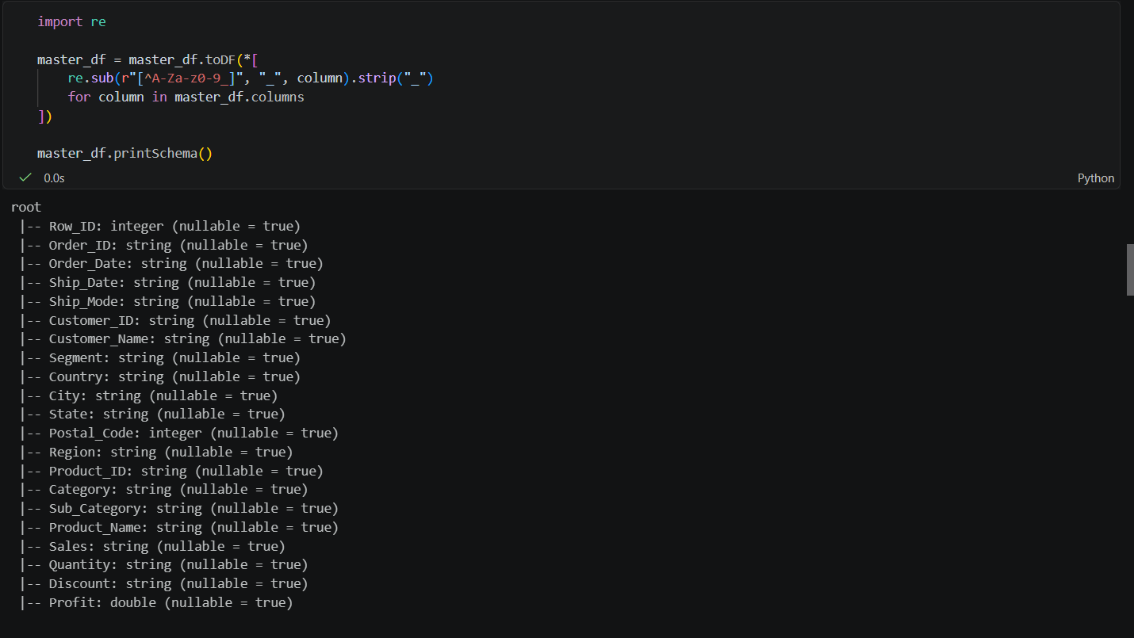
Figure 5: screenshots\data_loading\image2.png — execution evidence for data loading, cleaning, SCD Type 1/2 work, validation, or final output.
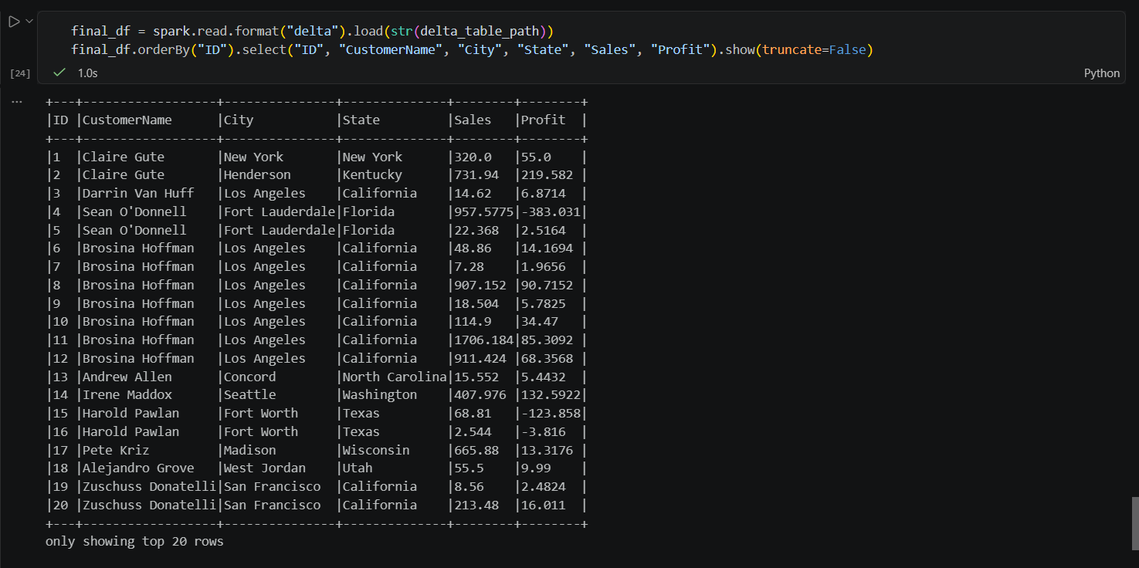
Figure 6: screenshots\final_output\image1.png — execution evidence for data loading, cleaning, SCD Type 1/2 work, validation, or final output.
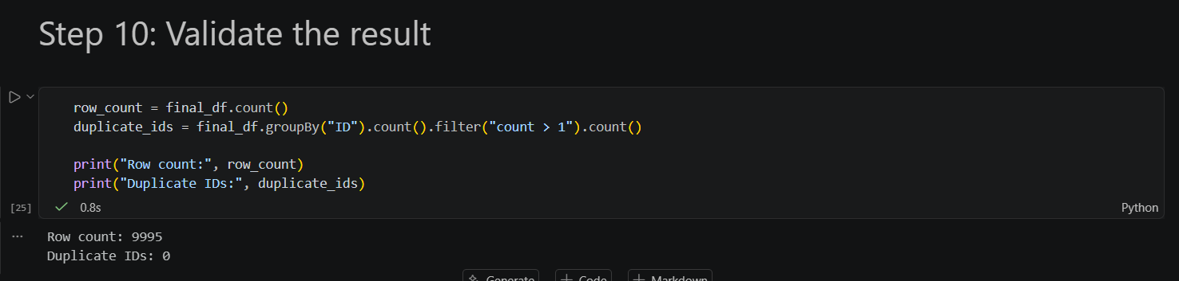
Figure 7: screenshots\final_output\image2.png — execution evidence for data loading, cleaning, SCD Type 1/2 work, validation, or final output.
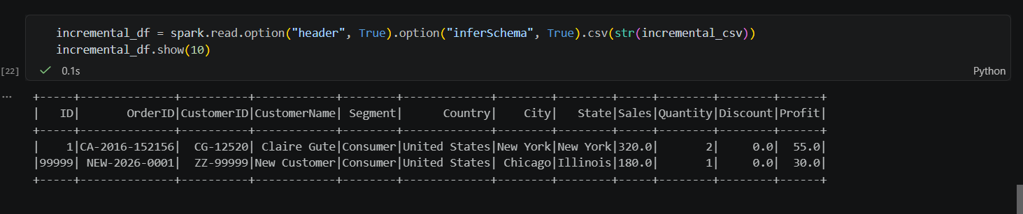
Figure 8: screenshots\scd1\image.png — execution evidence for data loading, cleaning, SCD Type 1/2 work, validation, or final output.
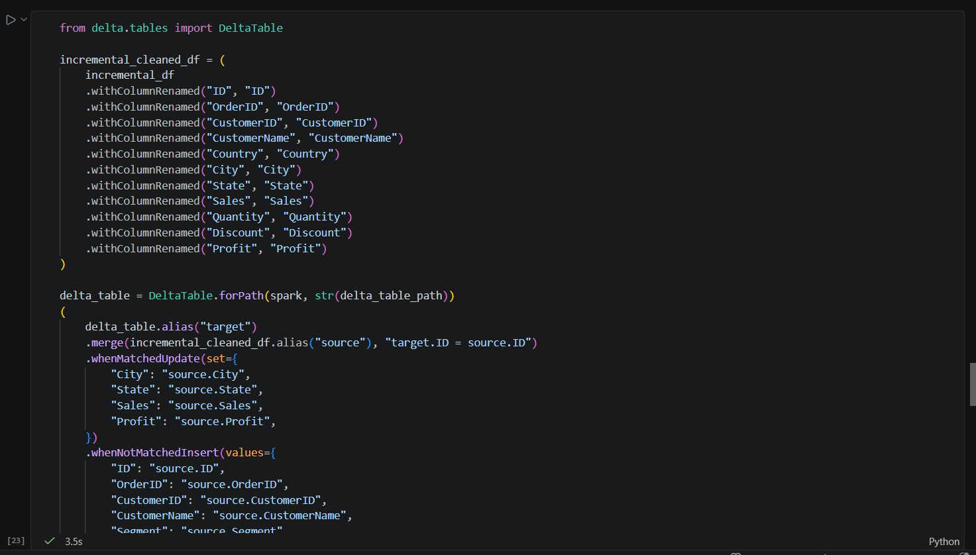
Figure 9: screenshots\scd1\image1.png — execution evidence for data loading, cleaning, SCD Type 1/2 work, validation, or final output.
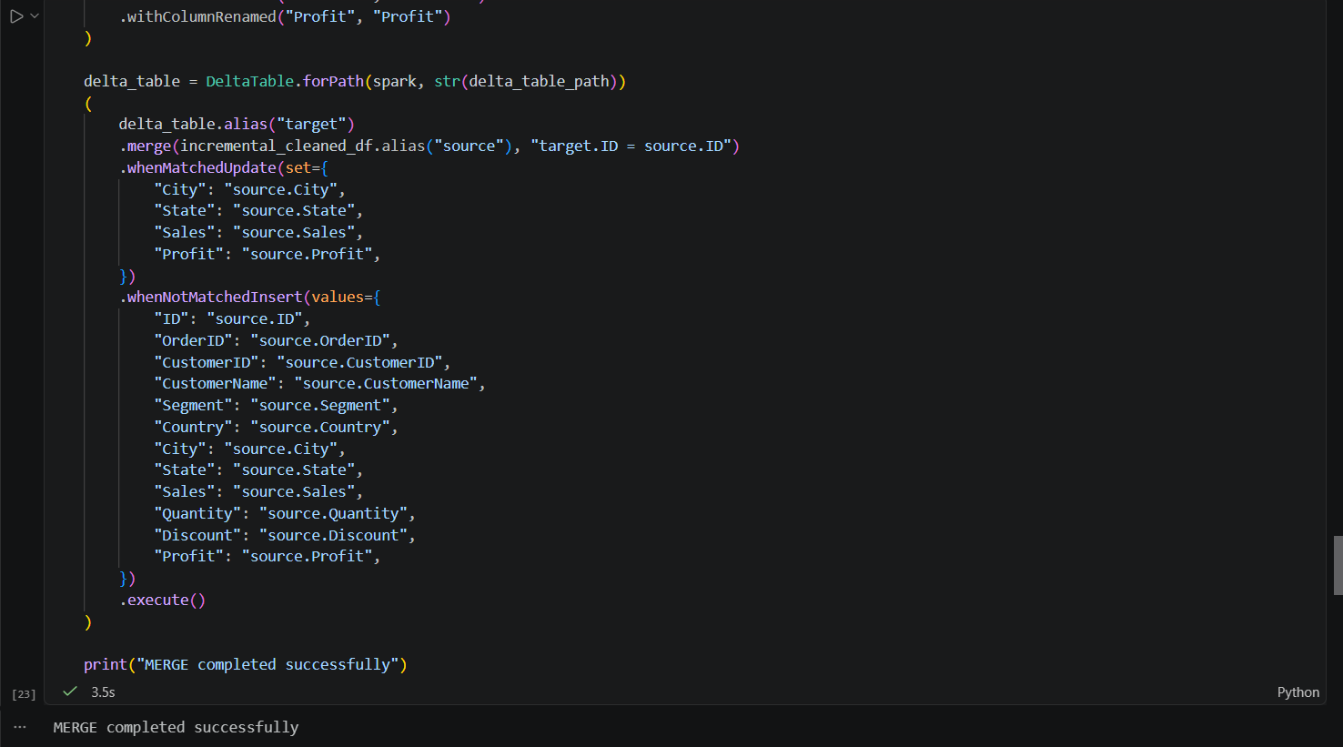
Figure 10: screenshots\scd1\image2.png — execution evidence for data loading, cleaning, SCD Type 1/2 work, validation, or final output.
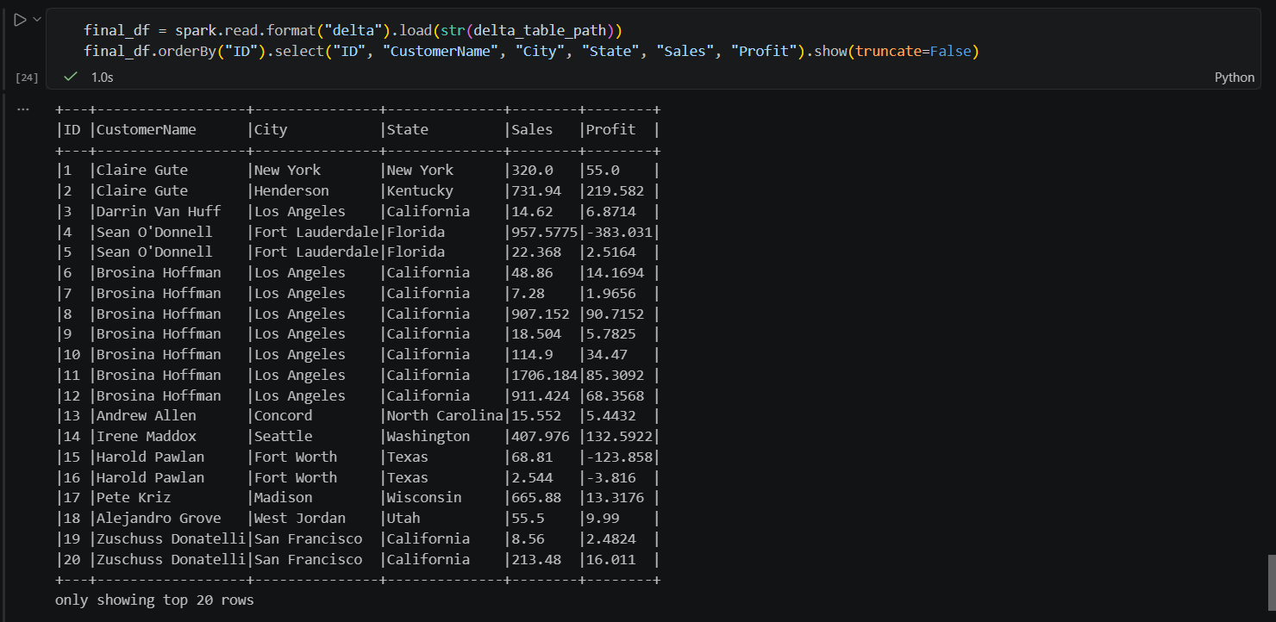
Figure 11: screenshots\scd1\image3.png — execution evidence for data loading, cleaning, SCD Type 1/2 work, validation, or final output.
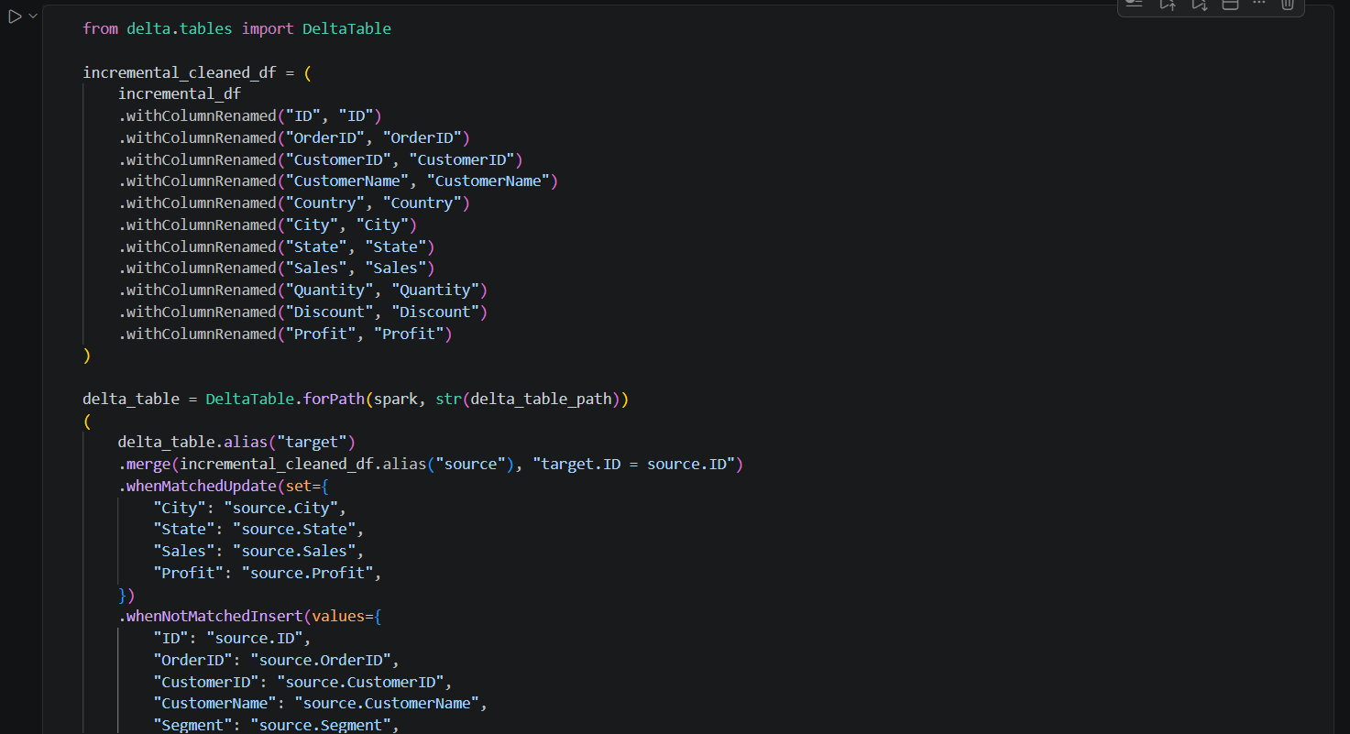
Figure 12: screenshots\scd2\image1.png — execution evidence for data loading, cleaning, SCD Type 1/2 work, validation, or final output.
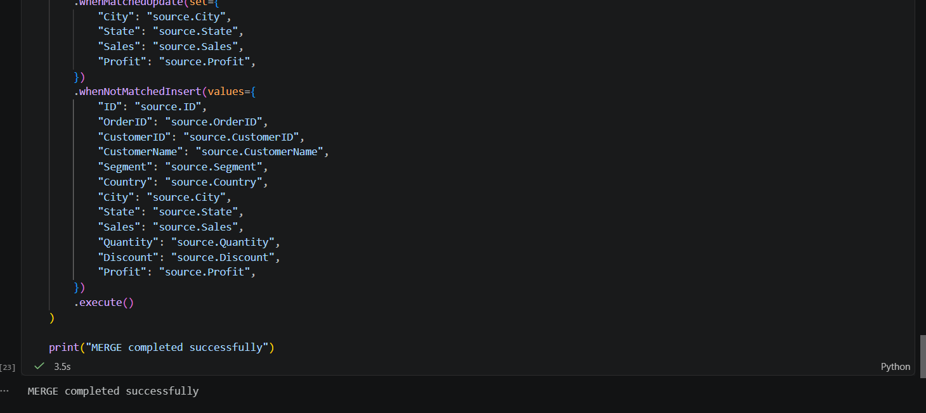
Figure 13: screenshots\scd2\image2.png — execution evidence for data loading, cleaning, SCD Type 1/2 work, validation, or final output.
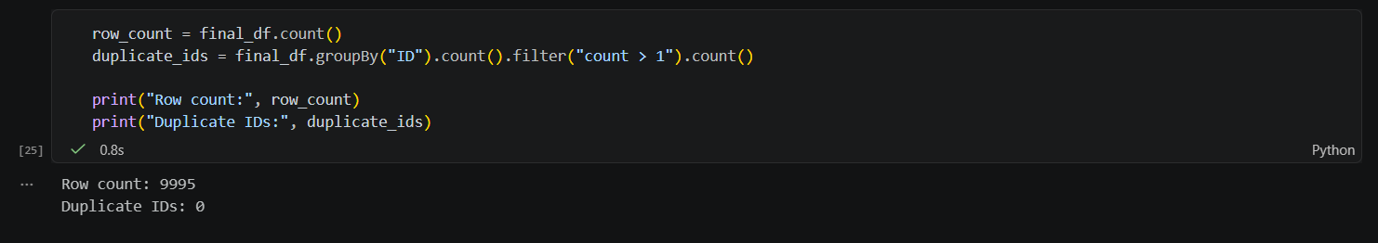
Figure 14: screenshots\validation\image.png — execution evidence for data loading, cleaning, SCD Type 1/2 work, validation, or final output.

15. Output Explanation
The screenshots provide evidence of data loading, cleaning, SCD processing, validation, and final output. The project README confirms that the Type 1 merge replaces matched customer values and adds new customers.

16. Results
Observed / expected result | Interpretation
Type 1 merge | Matched records receive latest attributes; unseen identifiers are inserted.
Standalone validation expectation | row_count = 4 and duplicate_ids = 0, as stated in README.
Delta artefacts | Both customer_master and superstore_master Delta folders include Parquet data files and _delta_log transaction history.

17. Analysis and Observations
The workflow separates ingestion, cleanup, Delta persistence, incremental merge, and validation. Type 1 behavior keeps current values only, making the final table suitable for current-state reporting rather than historical tracking.

18. Problems Encountered / Solutions Applied
No runtime errors are documented. The implementation handles expected data issues by replacing unsafe column characters, removing duplicate identifiers, filling missing City/State values, and validating duplicates after merge.

19. Conclusion
Assessment 7 successfully demonstrates a local Spark and Delta Lake Type 1 incremental merge pipeline with cleaning, storage, upsert behavior, and quality validation.

20. Learning Outcomes
- Configuring Spark for Delta Lake.
- Writing and reading Delta tables.
- Using Type 1 SCD merge logic.
- Validating merged datasets.
- Understanding Delta transaction-log storage.

